CAS PORTFOLIO 2024-2025
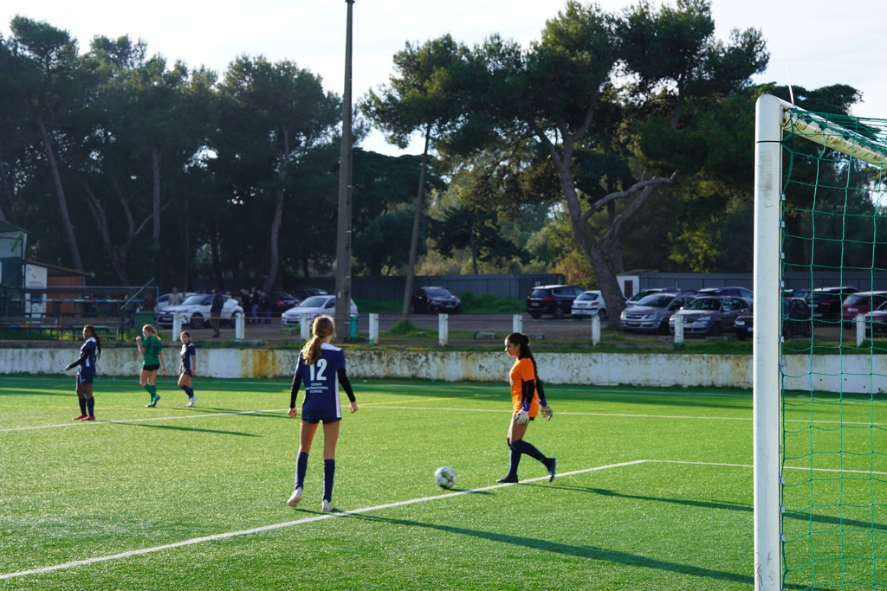
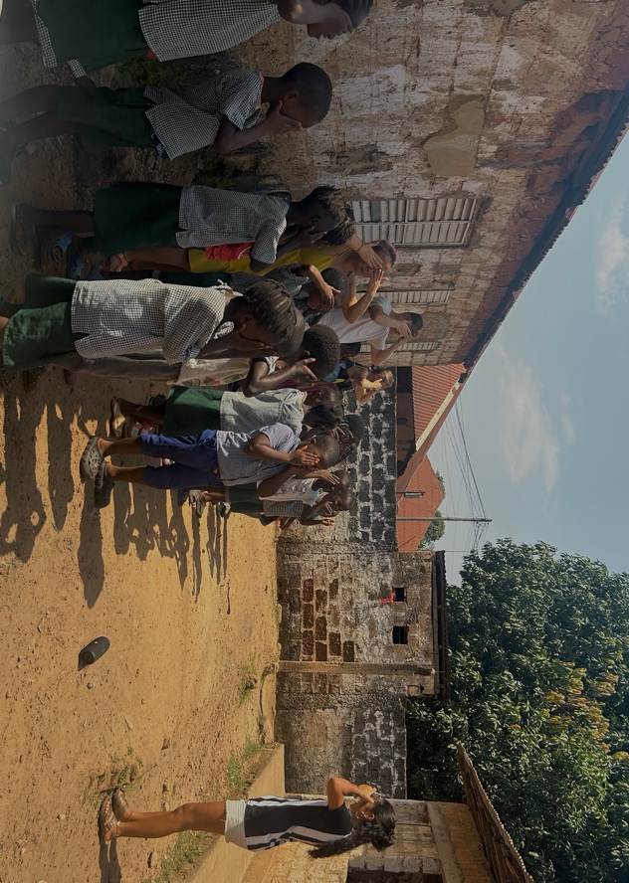
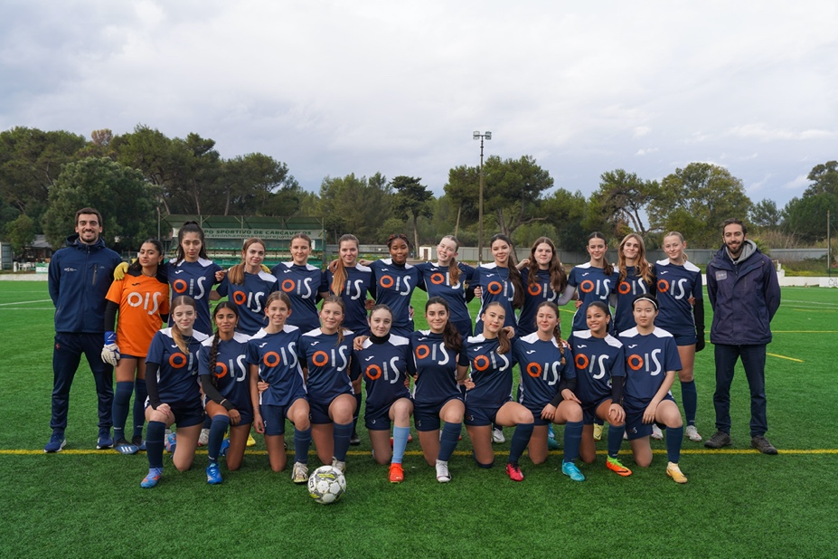
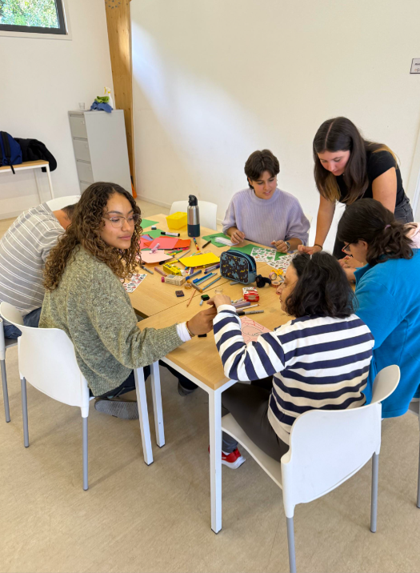
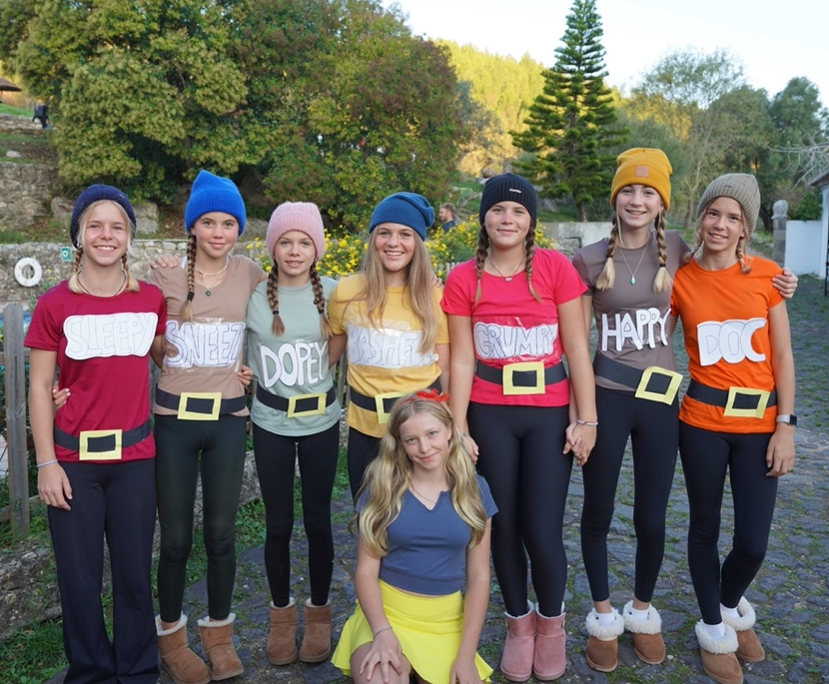
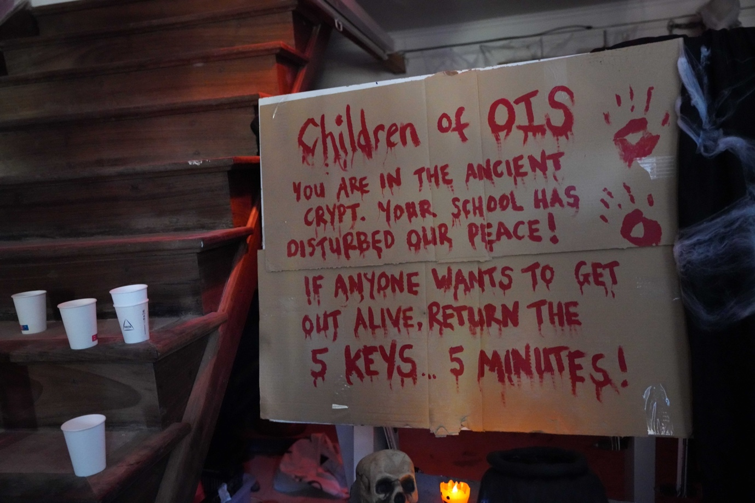
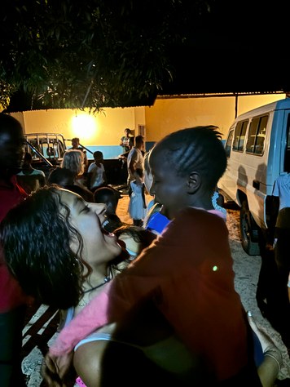

Demonstrate engagement with issues of global significance
Projects – Bombeiros Project and Guinea Bissau Missionary Trip

Bombeiro Project: Service
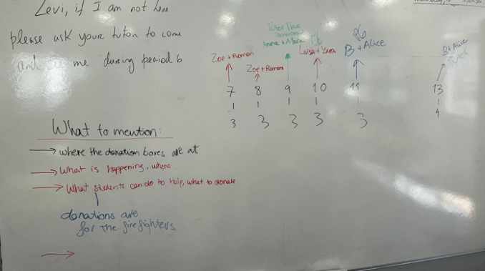
Inside the CAS strand Service, this activity was student initiated as a response to emerging urgent wildfires in the North of Portugal in the end of 2024. Some year 12 students and I incentivated an entire school donation to give firefighters essential items such as energy-rich food and burn cream. This is an example of how I have stepped into the global issues that matter: how climate-related disasters get to communities across the world, and the need to take action as a community to help. This project enabled me to develop teamwork and organization skills whilst having playing a part in engaging with a real-world issue.

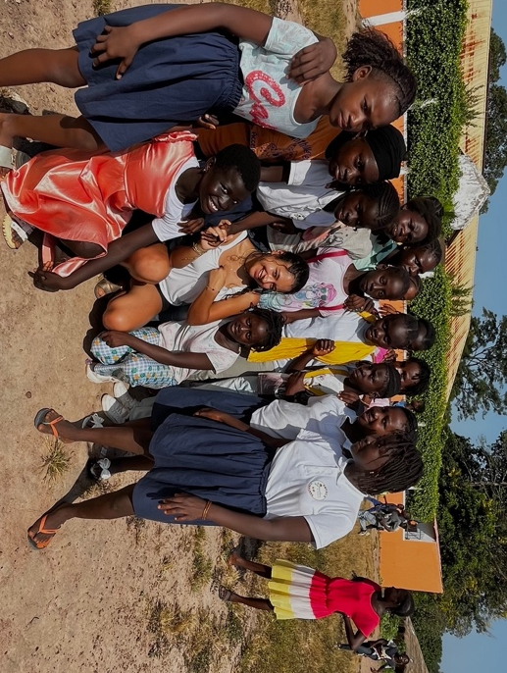
Guinea Bissau Missionary Trip: Activity, Creativity and Service
Belonging to the strands Activity, Service, and Creativity all in one, the Missionary Trip to Guinea Bissau that I had the privilege to attend was very immersive experience. This activity encouraged me to engage directly with global issues, developing my understanding of global poverty, limited potential for educational improvement and cultural inequity. I worked hard and was challenged physically, intellectually, and emotionally though teaching at schools, public speaking, preaching in churches, community service and creatively planning activities for children. Through cross cultural communication, I developed very significant skills that were essential for the works we planned on doing, including adaptability and leadership, while also engaging in conversations on the ethical implications of humanitarian work. This experience exemplifies the learning outcome of engaging with issues of global significance pushing me to open my mind to very different worlds, gaining a deeper understanding of a person’s role, not only though service, but also through genuine connection and respect. It was an eye-opening journey that ignited a passion for personal development and reinvigorated my commitment to creating meaningful change beyond borders.
Activity was met through the physically demanding work in trying conditions my team and I experienced. Activities with children most often involved sports and playing in high heats and unfamiliar settings. I also had the opportunity to connect with smaller children through teaching them dance moves and choreographies. Service was met through our active contributions to educational and social needs of school, churches, and orphanages across the region through multiple activities. Creativity was expressed in planning and delivering interesting lessons and games for children, tailored to cultural values, that would overall emphasize teamwork and self-expression.

Demonstrate how to initiate and plan a CAS experience

Projects – Head of Photography and Bombeiros Project

Head of Photography: Creativity
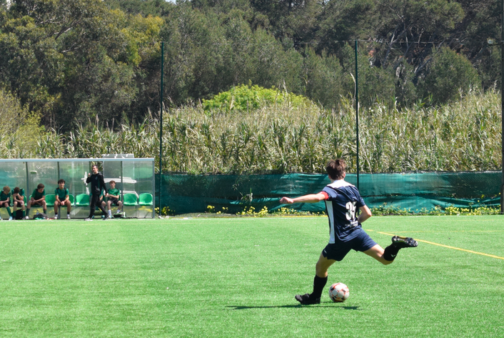
Having been part of the photography club for some years, this year I was asked to step up to be the club’s Leader. This has been extremely rewarding in creative leadership practice, where I was required to plan several projects, organize and ensure each student contributed while exploring their photographic talents, and taking part of many activities across this school year. Thus, this role has allowed me to demonstrate how to initiate and plan a CAS experience due to having to independently coordinate a school club, equipment, and significant school activities such as sports tournaments and the yearbook. Through this year, I have further developed skills such as managing timelines and collaborating with both students and staff to bring ideas to life.
Creativity was fulfilled by being challenged to think artistically and come up with solutions in real time, either finding the best way to display photographs for a school exhibition, capturing dynamic moments during school games, or even coming up with a fair system to judge an internal photography competition. Overall, I can see that creatively leading a club, while developing creative skills in photography has deepened my appreciation for this realm and an expressive and collaborative art.

Bombeiros Project: Service
Belonging to the strand “Service”, the Bomberos Project was a student initiative as a response to the urgent wildfire issue faced in the North of Portugal in 2024. The Bomberos Project gave me the chance to demonstrate initiative and planning in coordinating the entire school response to the Portuguese wildfire disaster. From recruiting a team of Year 12 students to producing effective posters, making tutor class presentations, and coordinating donation points, I had to think on my feet and logically organize it all within the school. Leading a project from scratch was a valuable experience, helping me develop skills in public speaking, delegating, and mostly, being able to have good communication toward a large crowd, ensuring everyone understood the seriousness of the situation.
Service was fulfilled since this activity emerged from an urging ongoing situation in order to support the firefighter community. By organizing and uniting the entire school into giving supplies to help Portuguese workers in front lines, this activity showed how a student led service can pave the way for meaningful impact when paired with initiative.

Demonstrate that challenges have been undertaken, developing new skills in the process
Projects – Language & Performance Play, Football Team and Guinea Bissau Missionary Trip

Language & Performance Play: Creativity
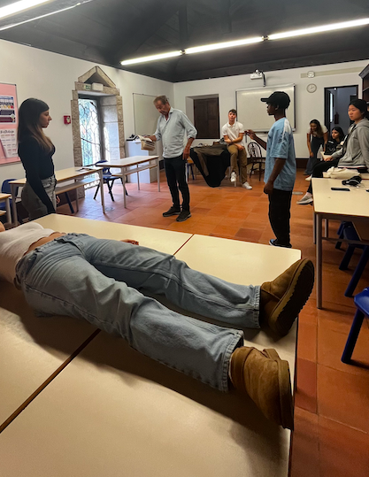
From the strand of creativity, the activity Language & Performance Play was challenging in multiple aspects, from learning to act and embody a complex character, to learning to think on my feet during high-stress situations such as live performances and gaining stage presence. This entire activity pushed me out of my comfort zone and allowed me to learn multiple skills through challenging aims, developing new skills in the process. The most important aspects I had to learn where voice projection, stage presence, improvisation, and patience, which helped me overcome unexpected errors and long backstage waits.
Creativity is directly correlated with this activity due to it being the key to the creative process of acting, character building, and live storytelling overall. Creativity was extremely present not only in student’s performances, but in the way we presented the play, and the stage set up.

Guinea Bissau Missionary Trip: Activity, Creativity and Service
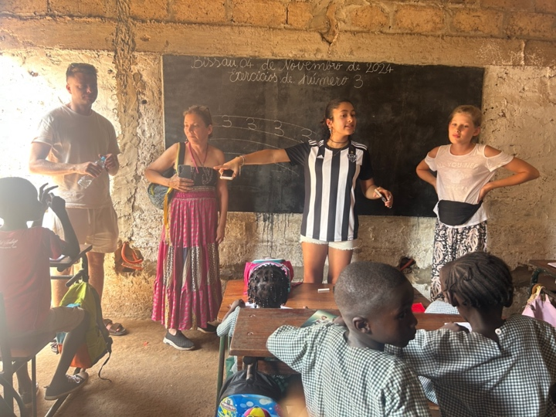
In 2024, I had the opportunity to go to Guinea-Bissau - a Portuguese-speaking country in Africa- for a missionary trip. The time I spend there was an adventurous joruney, filled with challenges like adapting to harsh climatic conditions and limited communication in the face of cultural and linguistic diversity. The obstacles I faced made me understand that flexibility, resilience, and a desire to help were key to overcoming these challenges. I also gained practical skills like public speaking before new audiences, improvisation in teaching and preaching, and using cultural sensitivity and ethical consciousness in each encounter. The experience imparted empathy-based leadership, thinking on one’s feet, and being able to work cooperatively under stress. In overcoming these difficulties, not only do I believe I have grown as a person, but I also acquired transferable skills which I will be able to apply in future humanitarian and international pursuits.

Demonstrate the skills and recognize the benefits of working collaboratively
Projects – Head of Photography, CECD, Football Team and Language & Performance play

Head of Photography: Creativity
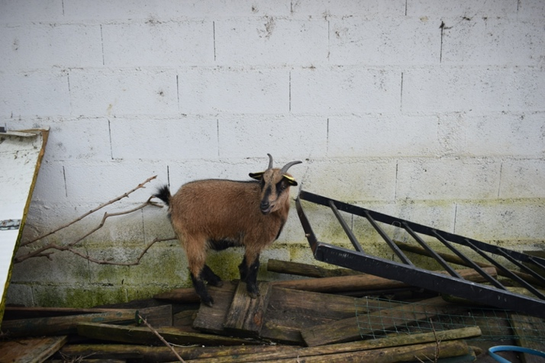
Being head of the photography club, this year has been a rewarding experience that has been pushing me to grow artistically and collaboratively. Through assigning responsibility and organizing event coverage, I ensured that everyone felt involved and had the opportunity to contribute, which helped create a more solid group dynamic and end product. I also felt more assured of my own photography skills, especially trying out natural lighting and different perspectives. Working with my peers, getting feedback from them, and seeing our overall progress allowed me to realize how much we benefit from one another's knowledge. Planning and leading the department challenged me to juggle responsibilities, but also to learn from others through hearing their suggestions. Overall, this exercise caused me to develop as a leader and an artist and showed me how beneficial collaboration can be to enhance the process and final product.

CECD: Creativity and Service
The CECD Project has been a rich experience that allowed me to exercise both creativity and service while improving collaboration and teamwork. Thoughtful events for adults with disability challenged me to be more creative, especially in designing activities such as the Christmas event, were my team and I were in charge of creating activities and gathering materials that were accessible and engaging. Service-wise, this activity has allowed me to consider how this project can directly impact individual’s lives through creating moments of joy and connection while being respectful and uplifting. By communicating directly with the CECD staff and assuming the role of the main point of contact, I established the value of continuity and accountability in service work. I had to manage expectations, adapt to challenges such as rescheduling events, and keep everyone informed and involved in the process.
Collaboration was central to our team in this project. Together, we were able to learn how to delegate, make moral decisions, and encourage participation from all members. Being a leader also taught me to listen more and pay closer attention to different voices in our group. By establishing an environment where everyone's opinions were heard, we became stronger and more effective as a team.

Football Team: Activity
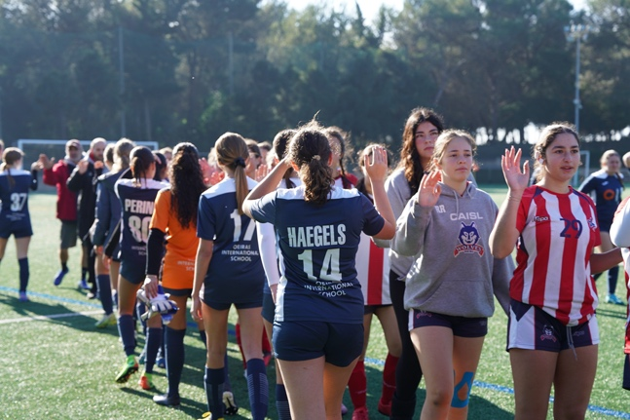
Through being part of the school’s Football Team as the goalkeeper, I have had the opportunity to represent our community in games and tournaments. Through this, I have come to deeply understand the value of collaboration and the strength that comes from being part of a committed tram. As the goalkeeper, my role naturally requires communication to ensure effective teamplay, simultaneously improving our team spirit. This being, the strand Activity has been met through challenging myself physically during practices and games, learning new skills and enhancing overall fitness. The goals I had initially set, being improving my goal kick and diving technique were attained though constant practice and feedback from my team. Their ideas and our shared will to be a better team gives each practice a purpose.
Collaborating had not only improved our team sports wise but has also taught me to be patient and communicate with respect from improved results. I have learned that being part of a team in not about showing up and performing for myself, but rather for the people around.

Language & Performance play: Creativity
Acting in our school’s DP Language & Performance play allowed me to gain the opportunity to exercise my creativity while learning the value of teamwork. Through rehearsals, I believe we all understood the importance of teamwork being critical to our success: we understood the necessity to have good communication, be adaptable, and motivate each other every step along the way. This experience revealed how creativity thrives in a team environment, where everyone’s input is important.
Collaborating has allowed me to adapt better, especially when unexpected events took place. I also deepened my understanding on the importance of teamwork and mutual respect for a successful project.

Identify own strengths and develop areas for growth
Projects – Guinea Bissau Missionary Trip

Guinea Bissau Missionary Trip: Activity, Creativity and Service
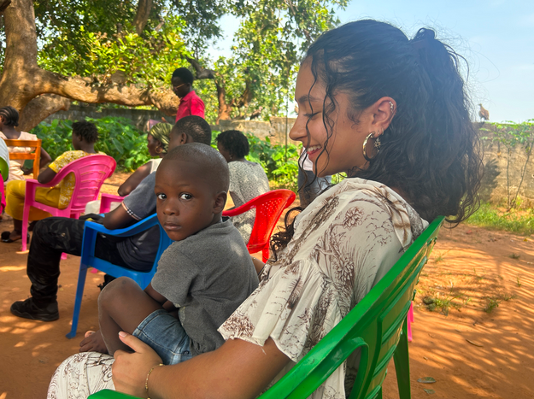
The mission trip in Guinea-Bissau was a life-changing experience where I discovered many qualities I already had, as well as many areas for growth. I undertsoof that I am able to easily conncet with other individuals, and adapting quick no unkown environemnts. Nevertheless, I also understood that I still have to iporve my patience and felxibility, espcially when plans get out of my control and have sudden changes.
This experience met the three starnds of CAS: Service was present throihh the direct community conatct we had, helping, donfing, and teaching. Activity was encountered through yhe physical activity I did through teaching sports to young kids. Creativity was met through our approaches to games, crafts, and interactive lessosns. These experiences pushed me beyond my comfort zone and showed me how much more I can grow if I challenge myself.

Recognize and consider the ethics of choices and actions
Projects – CECD and Guinea Bissau Missionary Trip

CECD: Creativity and Service
Working with CECD has taught me the importance of acknowledging the ethical consequences of our actions. As we planned activities for disabled individuals, we had to ensure we were inclusive, respectful, and empowering instead of unconsciously being simplistic or condescending. This forced us to have to reframe our concepts in a manner that they could be accessible but not boring, requiring group reflections and sensitivity.
Service was met through being able to help individuals respectfully and humanely, constantly aiming to foster and environment where they feel values. This was achieved through creativity, where we used creative exercises and activities, each molded around the participates and their needs. This activity reaffirmed my understanding of how ethical sensitivity guides purposeful and respectful service.

Guinea Bissau Missionary Trip: Activity, Creativity and Service

During my time in Guinea Bissau, I was able to fully grasp the idea and fully understand the importance of being aware of the ethical responsibilities that come with serving others in a different cultural context. Even with the best intentions, I learned how necessary it is to constantly reflect on our actions to ensure our actions were benefitting the people around us, and not the opposite. This was especially clear to me while preparing the games and activities for schoolchildren, where they had to be appropriate and adapted to their reality, ensuring we understood how it would be received, d not just how it looked from our perspective. This allowed us t be more culturally aware.

Show commitment to and perseverance in CAS experiences
Projects – Football Team

Football Team: Activity
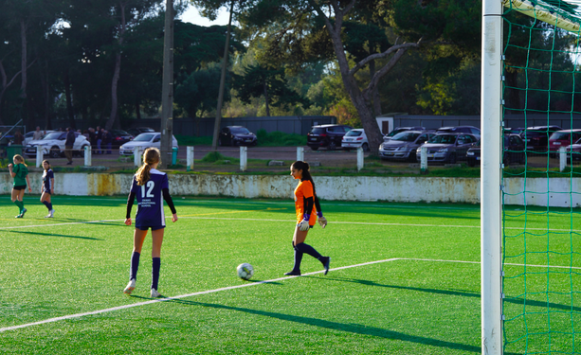
Being part of the varsity Football team has taught me a lot on commitment and perseverance, pushing through challenged. At first, I encountered struggles with certain essential goalkeeping skills, which would sometimes give me the desire to give up due to not learning fast enough. However, through persevering and attending all training sessions regardless of how tired I was, I started to see a slow yet steady progression in my performance. The consistency helped me stay committed to my goals.
Activity in this project does not only require physical effort but also mental resilience. When feeling discourage, I learned to focus on long term outcomes while working repeatedly during practices.

